Jessenia Garcia

Assignment #4

I wanted to see if there were statistical differences by race for unemployment and the source of my data is the Borough of Labor Statistics. My data consisted of unemployment rates from 1980- 2013 for White, Black, Hispanic, and Asian men and women between the ages 18-24.

I chose to start my analysis using a T-test to see if there was a difference between the total rate of unemployment of White individuals and the total rate of unemployment of Hispanic individuals. Table 1 below shows descriptive statistical differences between the two variables.

|  |  |  |  |  |  |  |  |
| --- | --- | --- | --- | --- | --- | --- | --- |
| Table 1. Descriptive Statistics for Total White and Total Hispanic Unemployment | | | | | | | |
| Variable | Mean | Standard Deviation | Min | Max |  |  |  |
| Total White | 10.15 | 2.27 | 6.9 | 15.2 |  |  |  |
| Total Hispanic | 13.58 | 3.08 | 8.6 | 20.1 |  |  |  |
| NOTE: Beginning in 2003, estimates for White, Black, and Asian race groups include people who selected that race group only. Prior to 2003, people who reported more than one race were included in the group they identified as the main race. Asian estimates for 2000–2002 are for Asians and Pacific Islanders; beginning in 2003, Asian is a separate category. Persons whose ethnicity is identified as Hispanic may be of any race. | | | | | | | |
| SOURCE: Bureau of Labor Statistics, Current Population Survey. | | | | | |  |  |

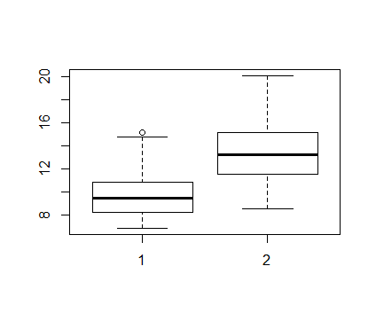

1 =White Unemployment Rate 2 = Hispanic Unemployment Rate

The T-test was first used to analyze if there was a difference. The T test indicated that the p-value was less than .05 and therefore was significant. The confidence interval was between -4.74 and -2.11. Because the data was not normally distributed, the Wilcox test was used and further verified that the p-value was less than .05.

I also wanted to know if there was a difference between White, Hispanic, and Asian groups. Table 2 below shows descriptive statistical differences between all the variables. It is important to note that statistics for Asian unemployment was not gathered until the year 2000. The unemployment rates prior to 2000 are unknown.

|  |  |  |  |  |  |  |  |
| --- | --- | --- | --- | --- | --- | --- | --- |
| Table 2. Descriptive Statistics for Total White Total Hispanic, and Total Asian Unemployment | | | | | | | |
| Variable | Mean | Standard Deviation | Min | Max |  |  |  |
| Total White | 10.15 | 2.27 | 6.9 | 15.2 |  |  |  |
| Total Hispanic | 13.58 | 3.08 | 8.6 | 20.1 |  |  |  |
| Total Asian | 10.02 | 2.66 | 6.6 | 13.8 |  |  |  |
| NOTE: Beginning in 2003, estimates for White, Black, and Asian race groups include people who selected that race group only. Prior to 2003, people who reported more than one race were included in the group they identified as the main race. Asian estimates for 2000–2002 are for Asians and Pacific Islanders; beginning in 2003, Asian is a separate category. Persons whose ethnicity is identified as Hispanic may be of any race. | | | | | | | |
| SOURCE: Bureau of Labor Statistics, Current Population Survey. | | | | | |  |  |

I completed T-tests to analyze the differences between three groups. The tests indicate that there is not a significant difference between White and Asian unemployment rates. The p-value was 0.87 which is greater than .05. Due to skewed data, I ran the Wilcox test and this verified that the difference was not significant.

There is a significant difference however, between Hispanic and Asian unemployment rates. . The p-value was 0.001 which is less than .05. Due to skewed data, I ran the Wilcox test and this verified that the difference was is significant. Below the box plots provide a visual representation of multiple group differences.

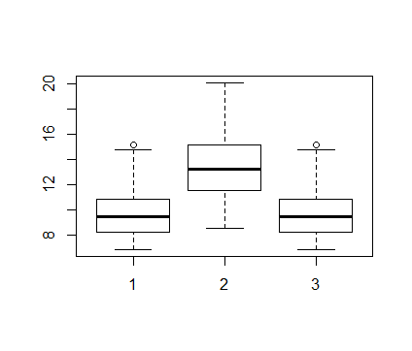

1 =White Unemployment Rate 2 = Hispanic Unemployment Rate 3 = Asian Unemployment Rate